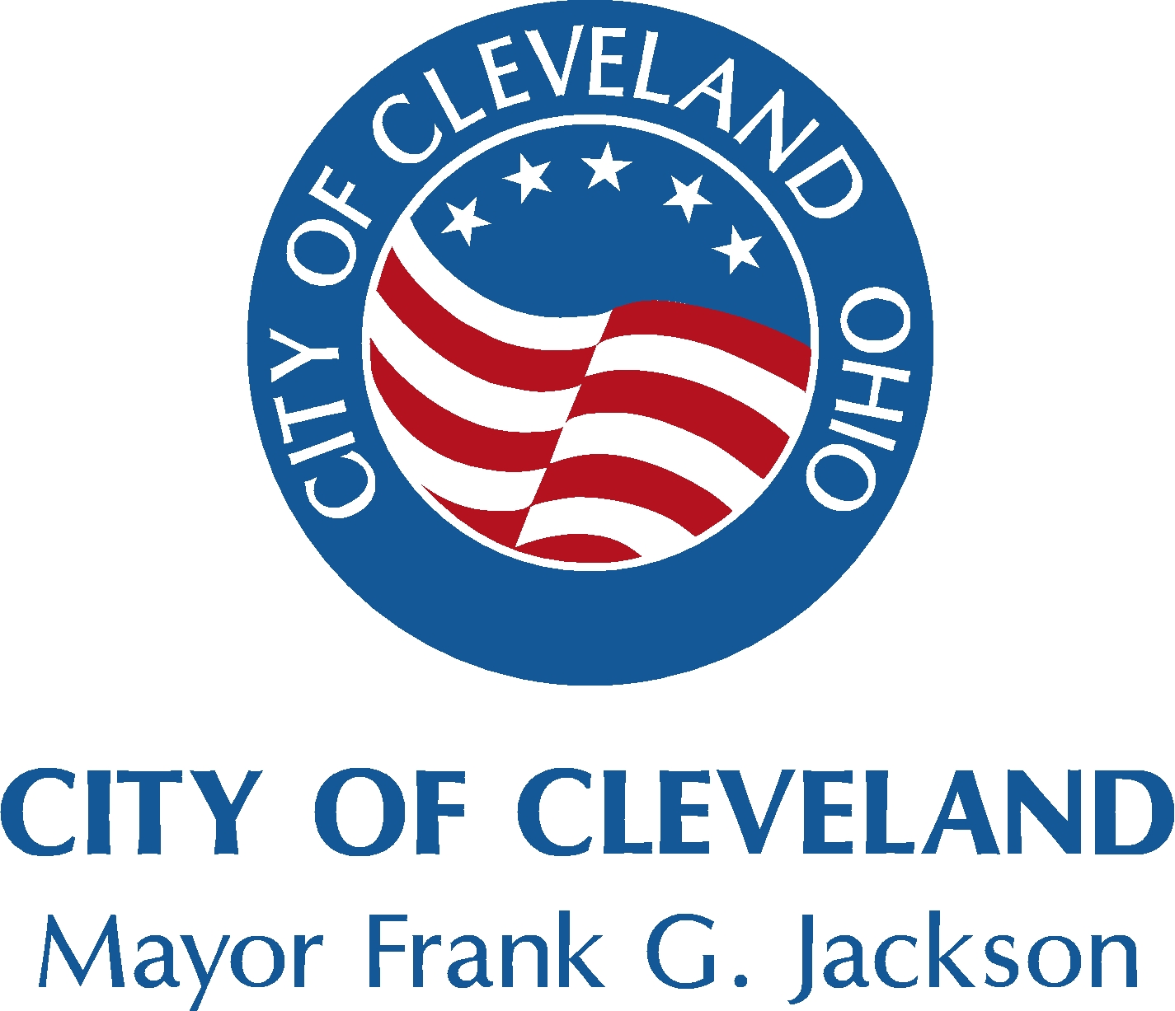
From: Department of Community Development
Redevelopment Development
Joseph A. Skrabec, Communications Manager
Department of Community Development
(216) 664-4597

Andrea V. Taylor, Press Secretary
Office of the Mayor
(216) 664-4171 or (216) 857-7998

Belinda I. Saldaña, Deputy Press Secretary
(216) 664-2223 or (216) 857-3808

FOR IMMEDIATE RELEASE:
February 2, 2009

MAYOR JACKSON INVITES CITIZENS TO

PARTICIPATE IN THE COMMUNITY DEVELOPMENT

BLOCK GRANT PLANNING PROCESS

CLEVELAND – Mayor Frank G. Jackson today extended a special invitation to all Cleveland residents and community stakeholders to participate in the upcoming Citizen Participation 2009-2010 community meeting focusing on spending of Community Development Block Grant (CDBG) funds.

THE CITIZEN PARTICIPATION 2009 MEETING WILL BE HELD ON THURSDAY, FEBRUARY 12, 2009, AT 10:00 A.M., AT THE CLEVELAND CONVENTION CENTER, ROOM 210, 500 LAKESIDE AVENUE.

“CDBG funds have made a significant impact on improving the lives of our citizens and the face of our neighborhoods for more than 33 years,” said Mayor Jackson. “Participation 2009-2010 is an important opportunity for our residents to voice their ideas and opinions on how to best utilize future CDBG funds to improve the City’s social service programming and neighborhood planning and development efforts.”

Each city receiving funds from the U. S. Department of Housing and Urban Development (HUD) is required to convene a citizens’ participation meeting where the community is given an opportunity to voice their opinions and concerns on the use and expenditure of CDBG funds within their communities and neighborhoods. The focus is on activities that can be implemented using funds from the four grants, which Cleveland receives on an annual basis:

- Community Development Block Grant (CDBG)
- HOME Investment Partnerships Program (HOME)
- Emergency Shelter Grant (ESG)
- Housing Opportunities for Persons with AIDS (HOPWA)

-More-

Cleveland’s Participation 2009-2010 -2-

Citizens Participation 2009-2010 will include collecting and analyzing all available data, meeting with various agencies and advisory boards, and soliciting input from citizens. The plan for the years 2009-2010 will be submitted to HUD in the spring of 2009.

The City of Cleveland is in the 34th year of the Community Development Block Grant program, and the U.S. Department of Housing and Urban Development (HUD) has allocated to the City of Cleveland a total of $962 million over the period.

During 2008 HUD awarded the City $23,601,124 million in CDBG funds. Based on need, the following represents last year’s CDBG annual allocation by major categories:

- Approximately $ 10.6 million (or 45 percent) is allocated to the Housing category that includes housing rehabilitation, new construction, and code inspection services.

- Approximately $ 3.9 million (or 16.7 percent) is allocated to Social Service programs that include services to seniors, youth, and families.

- Approximately $ 2.1 million (or 8.9 percent) is allocated for Commercial and Economic Development activities that include storefront renovation and CDC supported activities.

- Approximately $500,000 (or 2.1 percent) is allocated to Demolition and Board-up activities.

- Approximately $ 2.0 million (or 8.2 percent) is allocated to Property Maintenance activities that include Lot Clean-up and Community Gardening programs.

- The remaining $ 4.5 million (or 19.1 percent) is allocated for neighborhood planning activities, administrative cost for the Department of Community Development, and CDC support costs.

The City of Cleveland is currently in the process of finalizing the 2009-2010 budget.

For more information, please contact the Department of Community Development at 216/664-2869, or visit the What’s New section of the City’s Web site at www.city.cleveland.oh.us. Residents and stakeholders can also complete and submit a Citizens Participation Comments/Suggestions Survey located on the Department of Community Development’s Web page at www.city.cleveland.oh.us/community-development and click on the Did you know tab.and

-30-

