Estonian Cultural Garden

The garden was constructed in 1966. Clarence E. Van Duzer designed the monument and created a beautiful piece of public art. 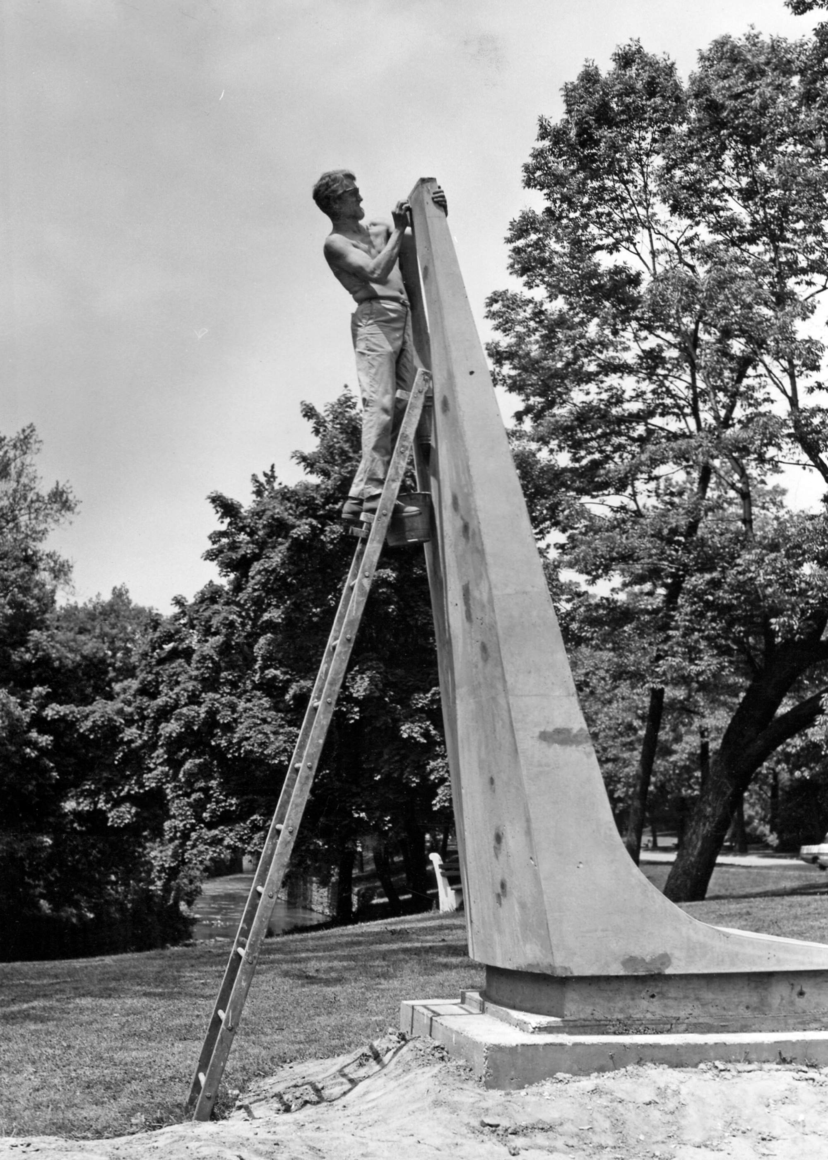

The monument is cast concrete and originally had a bronze flame and inscription. Upon completion, it was covered in crushed white marble.
The iscription ‘Aga ukskord algab aega…’ relates to the first line of the final verse of the Estonian national epic ‘Kalevipoeg’:
“But one day an age will dawn
when all torches, at both their ends,
will burst forth into flame;
and this stark fire will sever
the vise of stone from Kalevipoeg's hand.
Then the son of Kalev will come home
to bring his children happiness
and build Estonia's life anew.”

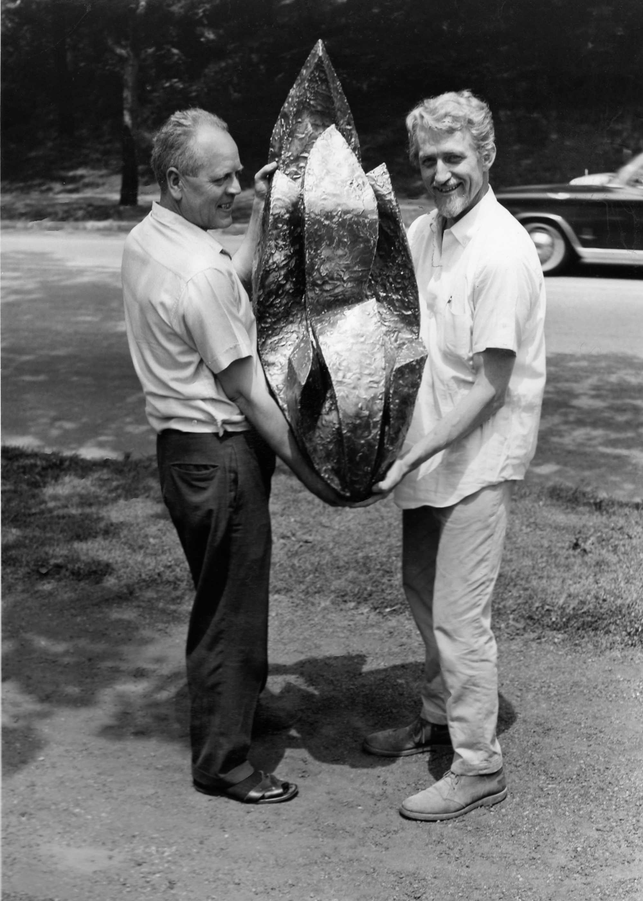
The picture is of Karl Tubalkain helping Clarence Van Duzer display the flame. Over the years, vandals have stolen the bronzes and the original crushed marble finish has faded. The Cleveland Police recovered the flame and plaque. We intend to use them as models for the restoration. The Estonian Cultural Garden committee is beginning a project to restore the garden to its original glory, redoing the walkway, landscaping and restoring the monument.

